# LABORATORY EXERCISE 5

# ADMIN, TEACHER, AND STUDENT DASHBOARDS

**Learning Objectives**

By the end of this laboratory exercise, students should be able to:

* Differentiate user roles and implement role-based access control (RBAC).
* Create distinct, role-specific dashboards within a single application.
* Develop dynamic navigation bars that change based on user role.
* Utilize CodeIgniter's Session library to manage user state and permissions across pages.
* Apply Bootstrap components and layout techniques to create informative and user-friendly dashboard interfaces.
* Implement authorization checks to restrict access to specific functionalities.

**Prerequisite student experiences and knowledge**

Before starting this exercise, students should have:

* Completed Laboratory Exercise 4 (User Authentication).
* A functioning login/registration system with a `users` table containing a `role` field.
* Understanding of CodeIgniter controllers, views, and session management.
* Basic proficiency in HTML, PHP, and Bootstrap grid system & components.
* Ability to write simple SQL queries and use the CodeIgniter Model.

**Background**

Most real-world applications serve different types of users, each with unique privileges and needs. A Learning Management System (LMS) is a prime example, typically involving Administrators (manage system, users, courses), Teachers (create content, manage grades), and Students (view courses, submit work).

This exercise focuses on building upon the authentication system from Lab 4. After a user logs in, they must be redirected to a dashboard tailored to their role. The application must also protect these dashboards, ensuring users cannot access areas reserved for other roles, a concept known as Role-Based Access Control (RBAC).

**Materials/Resources**

* Personal Computer with Internet Access
* XAMPP/WAMP/LAMP server installed
* CodeIgniter Framework (latest version)
* Visual Studio Code or any code editor
* Git and GitHub Account
* Web Browser (Chrome, Firefox, etc.)
* Pass the user's role and relevant data to the view.

**Step 4: Create a Unified Dashboard View with Conditional Content**

1. Create or modify the dashboard view at **app/Views/auth/dashboard.php**.
2. Use PHP conditional statements to display different content based on the user's role.

**Step 5: Create a Dynamic Navigation Bar**

1. Modify your header template (**app/Views/templates/header.php**) to include role-specific navigation items accessible from anywhere in the application.

**Step 6: Configure RoutesLaboratory Activity**

**Step 1: Project Setup**

1. Open your existing ITE311-LASTNAME CodeIgniter project.
2. Ensure your database has a **users** table with a **role** column: **admin, teacher, student**.
   * If not, create a new migration to alter the table.
3. Verify that the login process from Lab 4 correctly stores the user's **role** in the session data.
4. Open your previously created CodeIgniter project **ITE311-LASTNAME**.
5. Ensure your local server and database are running.
6. Open a terminal/command prompt in your project root.

**Step 2: Modify the Login Process for Unified Dashboard**

1. Navigate to your **Auth.php** controller.
2. Locate the **login()** method where user credentials are verified.
3. After a successful login, redirect everyone to a generic **dashboard** and implement a conditional check on the user's **role** from the session.

**Step 3: Enhance the Dashboard Method in the Auth Controller**

1. In your **Auth.php** controller, locate the **dashboard()** method.
2. Enhance this method to:
3. Perform authorization check (ensure user is logged in).
4. Fetch role-specific data from the database.
5. Ensure your **app/Config/Routes.php** has the correct route for the dashboard:
   * $routes->get('/dashboard', 'Auth::dashboard');

**Step 7: Test the Application Thoroughly**

1. Register or manually create users in your database with different roles (**admin, teacher, student**).
2. Log in with each user and verify:

* All users are redirected to the same **dashboard** URL.
* The dashboard displays different content based on the user's role.
* The navigation bar shows appropriate menu items for each role.
* Users can only see and access functionality intended for their role.

1. Test the logout functionality and access control.

**Step 8: Push to GitHub**

1. Commit your changes with a descriptive message.
   * At least five commits and it should be 4 days before submission are required to identify the progress of version control of the code or syntax.
   * Commit: "ROLE BASE Implementation"
2. Push the changes to your GitHub repository.

**Step 9: Vulnerable Checking**

1. Secure the **students** login and registration process so there is no vulnerability in the login procedures.

Output / Results

* Screenshot 1: The **user's table shows** users with different roles.
* Screenshot 2: When logged in as an admin, the dashboard view shows admin-specific content.
* Screenshot 3: When logged in as a teacher, the dashboard view shows teacher-specific content.
* Screenshot 4: When logged in as a student, the dashboard view shows student-specific content.
* Screenshot 5: The navigation bar displays different menu items for admin vs student users.
* Screenshot 6: The GitHub repository shows the latest commits.

**QUESTIONS:**

1. Authorization vs. Authentication: Based on your implementation, explain the difference between authentication from Lab 4 and authorization from Lab 5. Where in your code did you implement authorization?

**Ans**: In lab 4 it is where it identify the user in login() where the user is required to fill the form and with the use of usermodel to access the database the form and the existing data will be check if it is the same it will be redirect to dashboard() where it will show the user the dashboard view while in Lab 5 it authorize the user what display will be shown in the dashboard and on my case in the sidebar like the admin is authorized for the statistics view of student and teacher users and for user management table and for student they can only access the student dashboard. The dashboard contents will change depending of the user role and that is an example of Authorization in Lab 5.

1. How does the dashboard view determine which content to display? Explain the role of the session variable in this process.

**Ans**: In my code it change the view because of the if, elseif where I check the role of the user if it is equal to admin, teacher or student and the role of the session variable to to bring the user in other views with their credentials are intact the in this lab I used the session() to get the credential of the user and put it in data array I used if elseif condition to change whats the data inside because in step 3.2 it says stated that I needed to fetch it but it is okay if I just session check in dashboard to change the contents

1. If we wanted to add a new user role, what changes would be required in the current implementation to support this new role?

**Ans**: I would be the user table we add a new role in ‘role’ attribute and add the elseif in dashboard() where I will set the data to return view in the dashboard and another contents for that user that uses session check or $role check that is appointed to that role.

**Output / Results**

Screenshot 1: The **user's table shows** users with different roles.

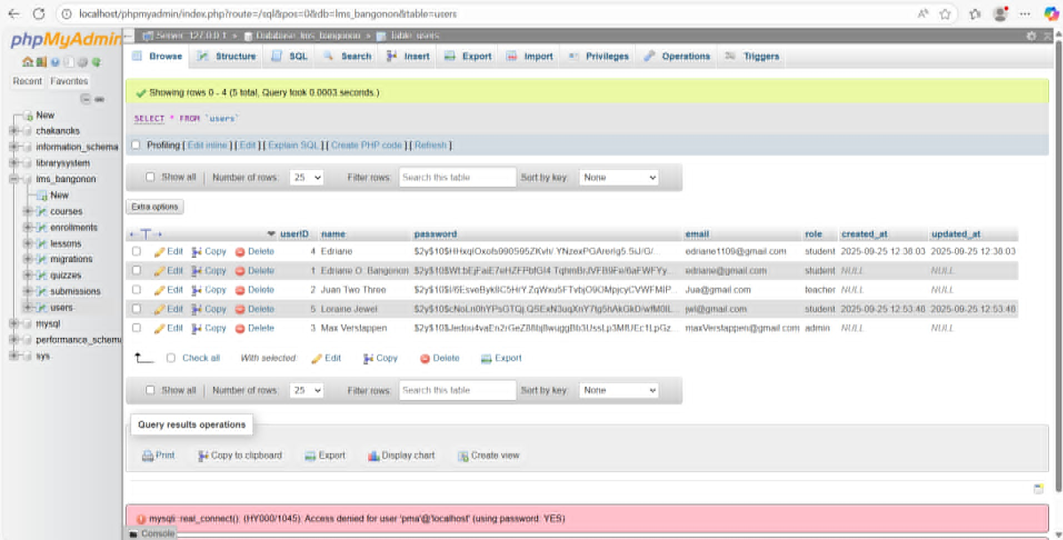

Screenshot 2: When logged in as an admin, the dashboard view shows admin-specific content.

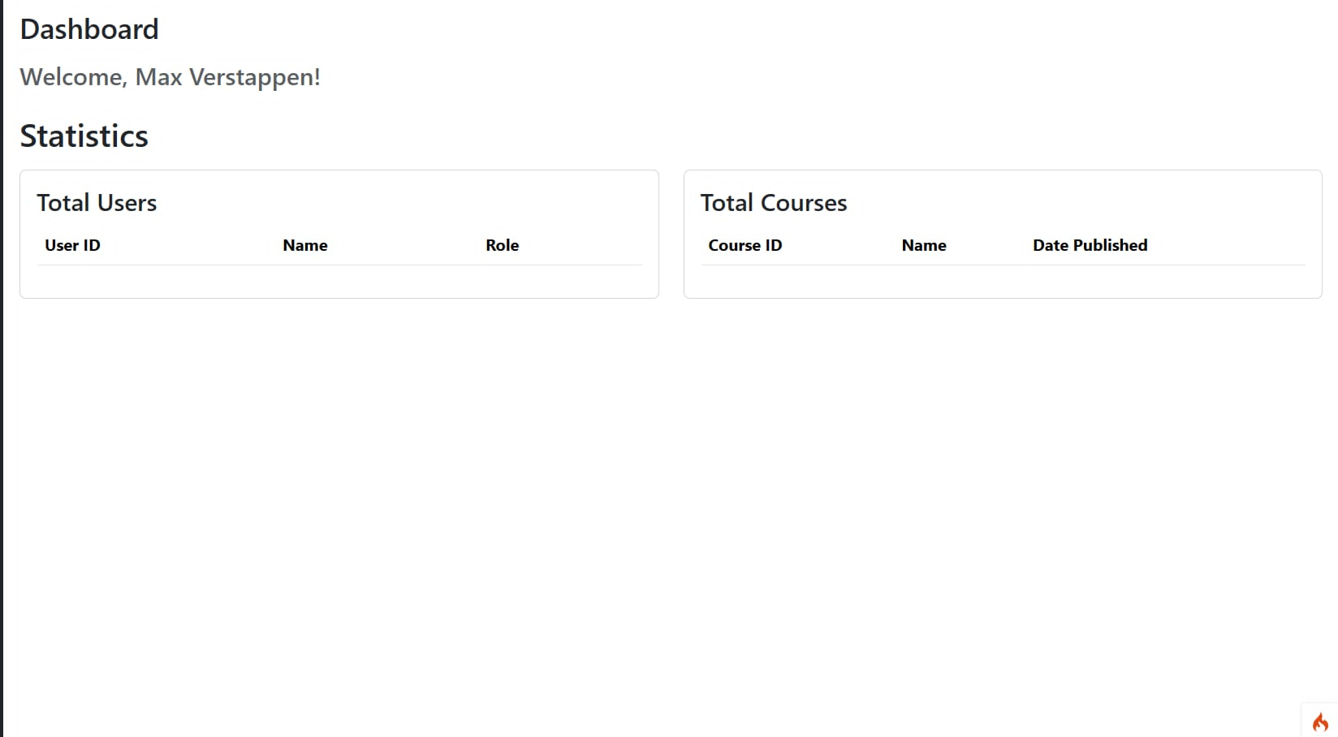

Screenshot 3: When logged in as a teacher, the dashboard view shows teacher-specific content

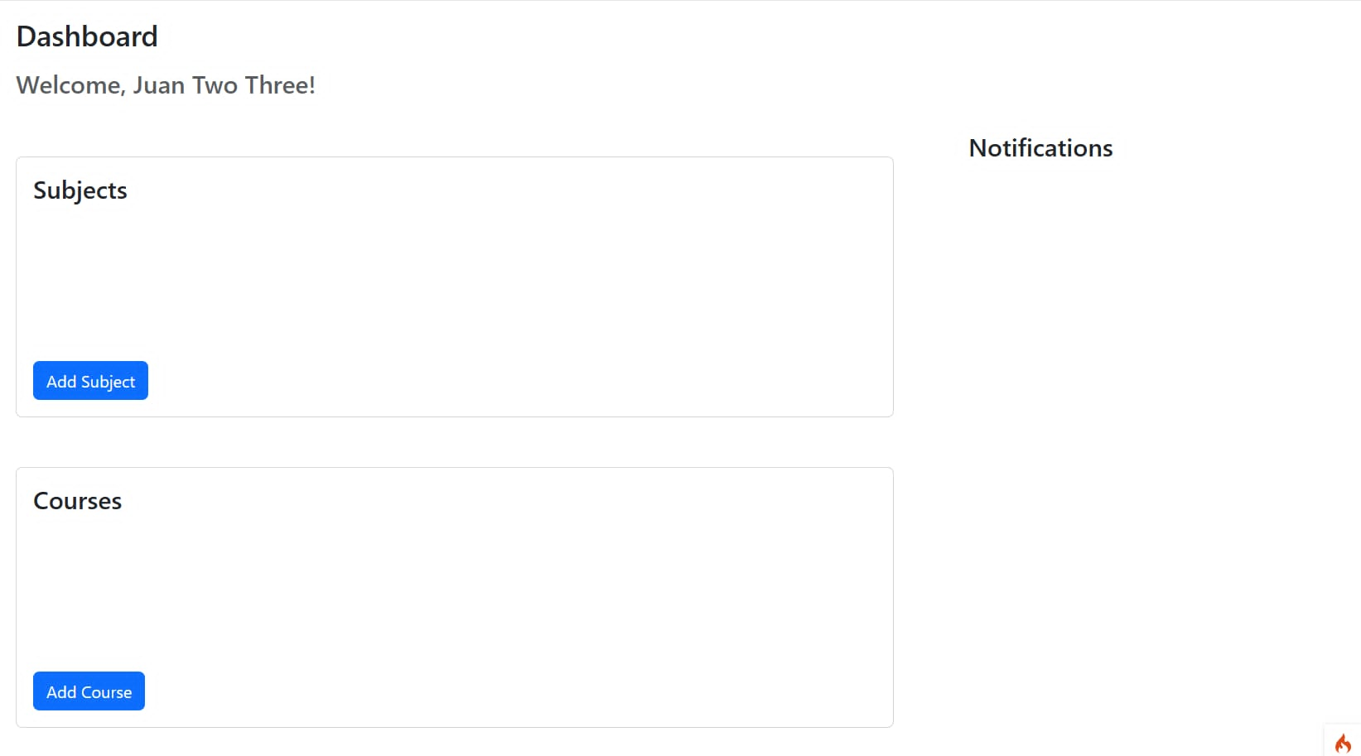

Screenshot 4: When logged in as a student, the dashboard view shows student-specific content.

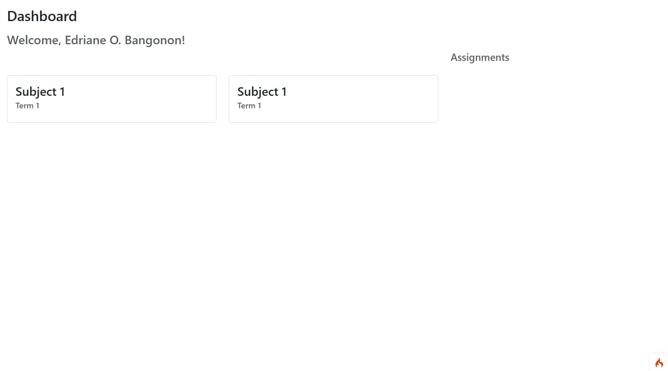

Screenshot 5: The navigation bar displays different menu items for admin vs student users.

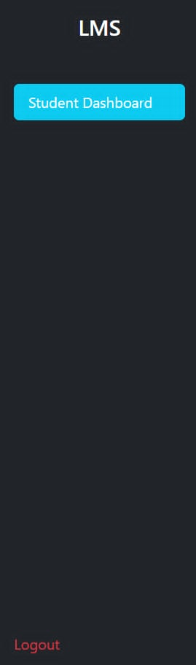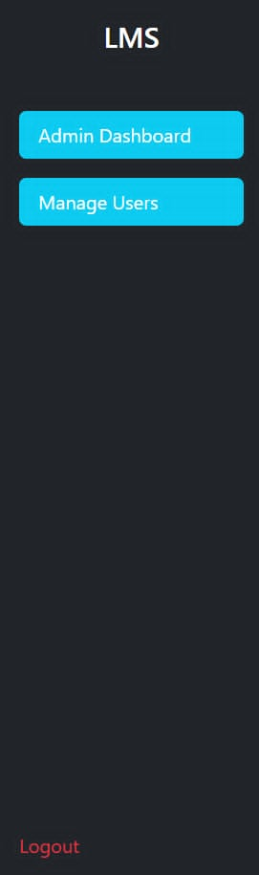 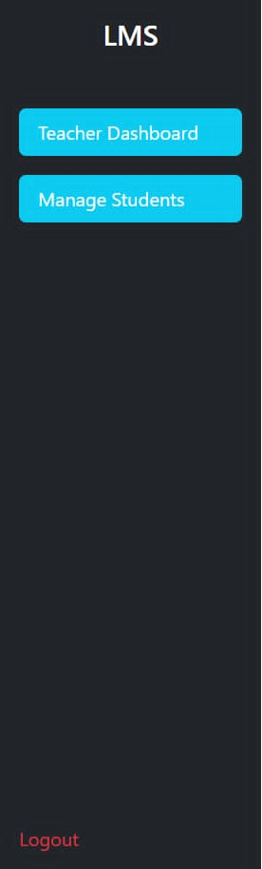

Screenshot 6: The GitHub repository shows the latest commits.

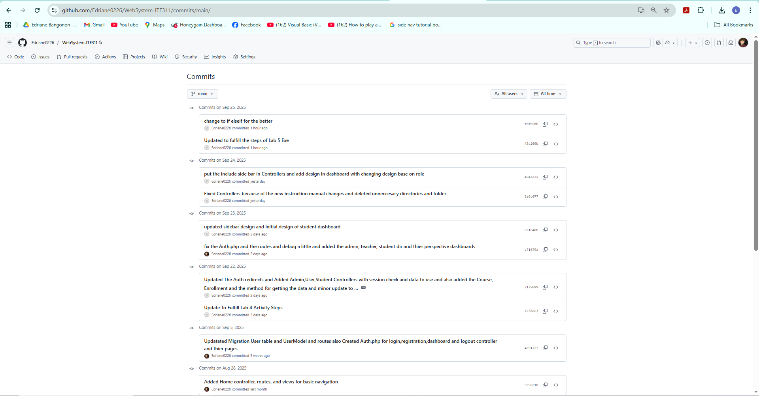

**Conclusion**

In this Laboratory Exercise I learned how to handle Authorization of different role and it is very helpful because what I am doing before this lab is to do multiple dashboard or pages for different roles and it is very helpful for me because I don’t need to write to many repeat codes, and also of how to handle the session properly like using it as a condition and many more that I didn’t know yet.